

HD Whale Wallet

Blockchain and Cryptocurrencies Project

[**GITHUB Repository**](https://github.com/ibra303/WHALE-WALLET.git)

**Students**

Habib Ibrahim – 207530940

Majd Zbedat - 314744822

Contents

1. Sign-In 2

2. Create New Wallet 3

3. Profile Page 4

4. Sending and Receiving Coins 5

5. Restore Wallet 10

6. General Tips and Notes 11

# Sign-In

The user is required to log in to the system via the Login.HTML page. If the user already has a wallet, they should use this to **sign in**. Otherwise, they should proceed to the registration page to **create a new wallet**.

Furthermore, users have the option to review a graph of the crypto market cap, ascertain the size of the market, and become motivated to start using the wallet.

# Create New Wallet

If the user does not have a wallet, they may click on the 'Create wallet' option to select a username and password for their new wallet.

NOTE: **We created a new wallet, but other wallet was used to simulate the functionality of other features**, **It is possible that the address and user name displayed may differ from those originally provided.**

Users can check if their password is strong enough

Upon completion of the sign-up process, users will be provided with a new account address, which will enable them to receive currencies. Additionally, users will be issued a 12-word phrase, which can be used to restore their wallets if they forget their passwords. It is imperative that users retain this phrase, as it will be required for wallet restoration.

# Profile Page

Once the user has successfully logged in, they will be able to view their profile page, which will display their name, wallet address, ETH and AVAX amounts, and their respective prices. Additionally, the user will have the option to enter the TradingView graph to monitor any currencies they wish to.

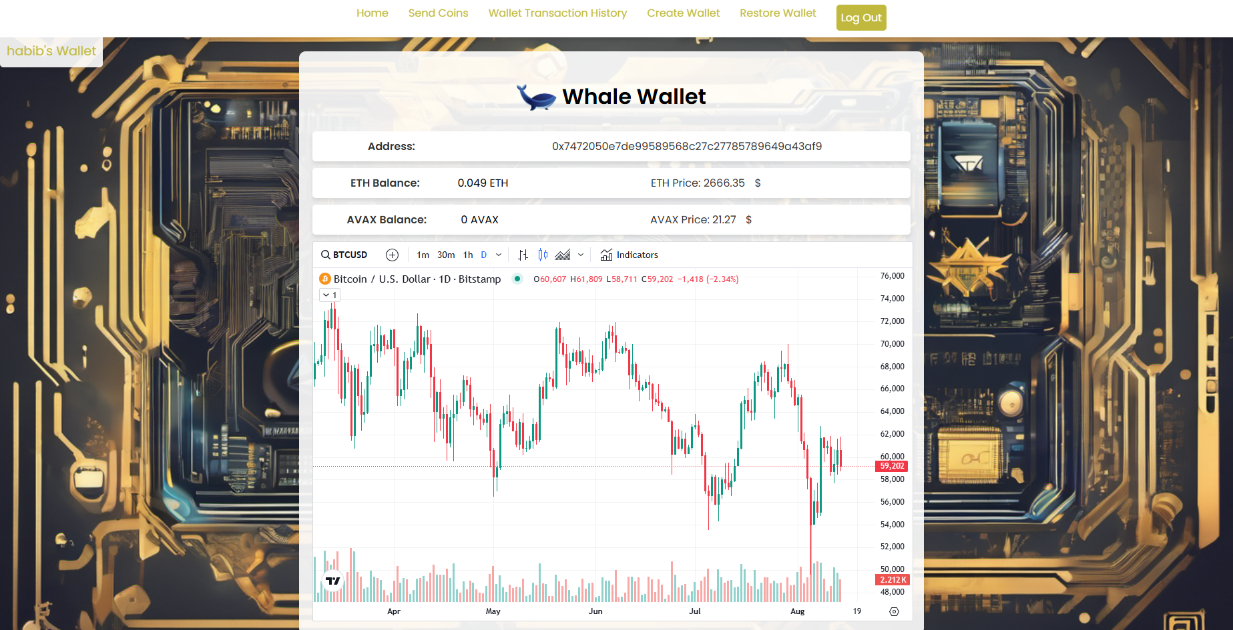

The user can check any currencies they wish, change the timeframe, and apply indicators to the graph.



# Sending and Receiving Coins

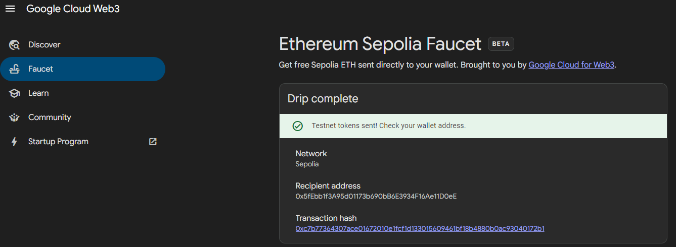To simulate the transfer of coins from and to the wallet, we utilised [Google Cloud Web3](https://cloud.google.com/application/web3/faucet/ethereum/sepolia) to obtain some test-net coins on the Ethereum Sepolia test-net.

0.05 ETH has been transferred to the Metamask wallet.

Subsequently, the ETH was transferred to the user's wallet, using the address provided upon registration.

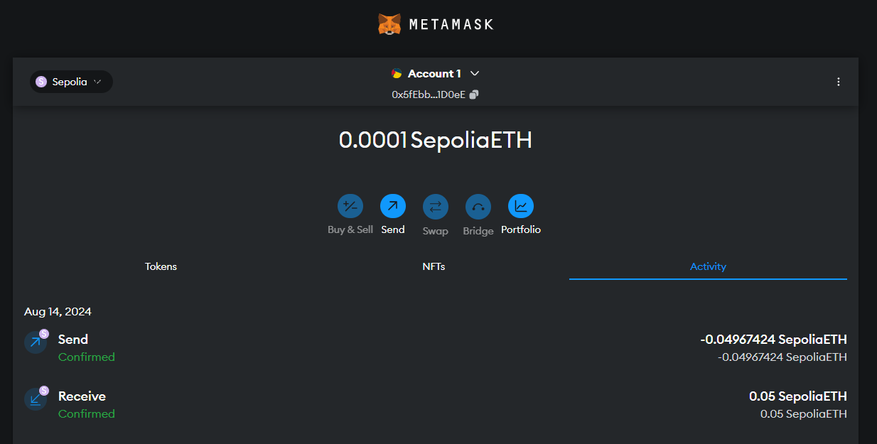

The transaction was completed successfully, and our account now shows 0.05 ETH.

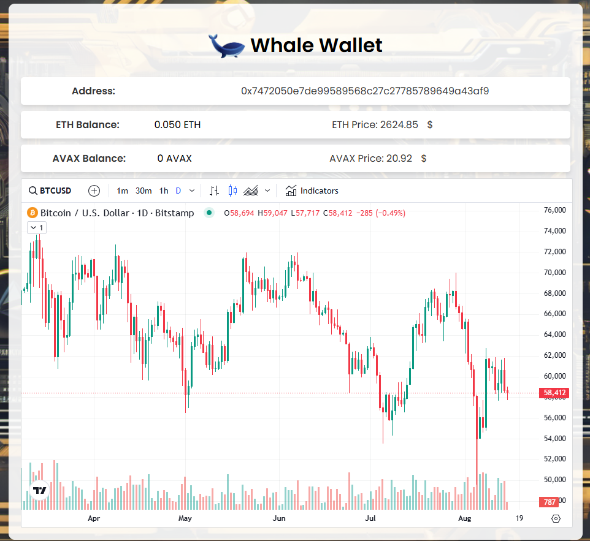

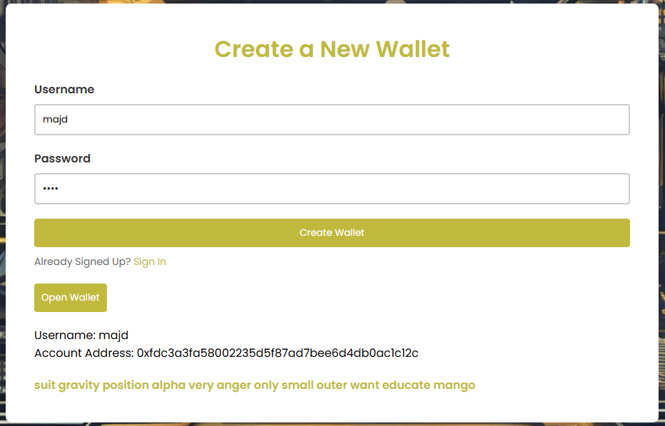Now we new account is now being opened with the intention of transferring coins to it.

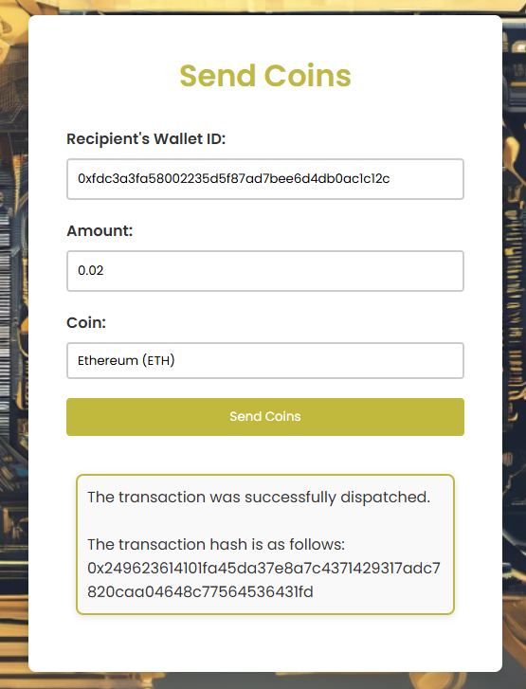We resume our examination of the primary account and proceed to the page designated for the transmission of coins.

The user address to which the tokens are to be dispatched.

The transaction was successfully completed, and the transaction ID has been provided for verification purposes.

The next step is to ascertain the value of the ETH account following the transaction. It is evident that the value has decreased by 0.02, in addition to the incurred gas fees.



Furthermore, the account to which we are sending the tokens should have a balance of 0.02. (the account balance was 0.001)

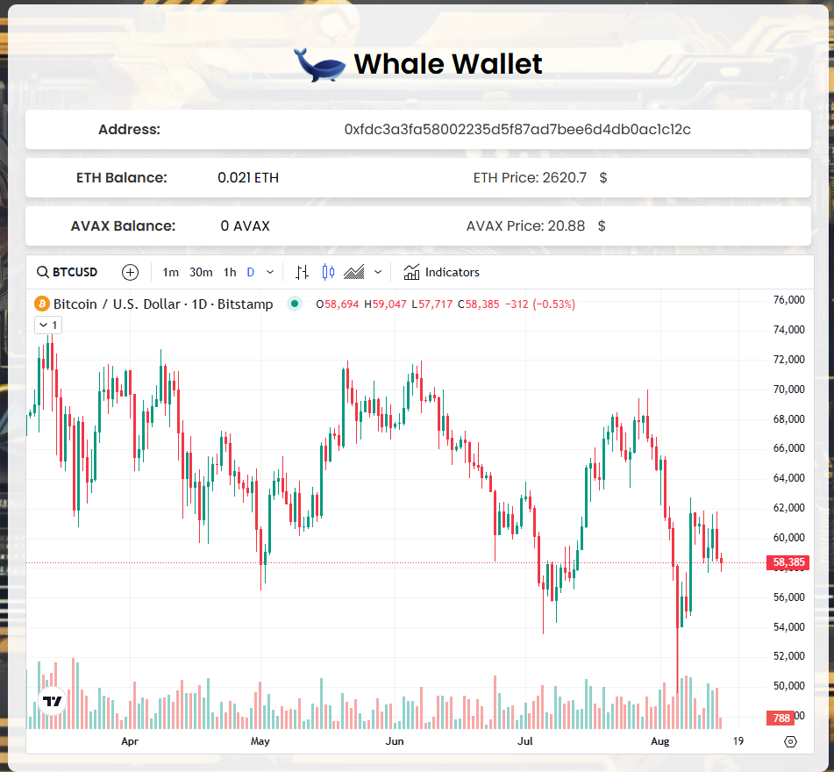

Also, we can see the verification of the transaction in [Etherscan](https://sepolia.etherscan.io/tx/0x249623614101fa45da37e8a7c4371429317adc7820caa04648c77564536431fd).

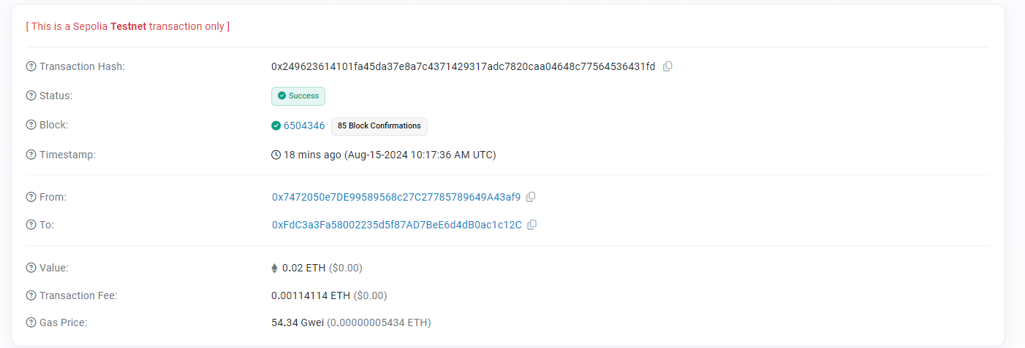

In addition to the Etherscan website, it is possible to access the wallet and view the signed transactions that have been made. To do so, the user should click on the option labelled "Wallet Transaction History," which will display all the transactions that have been made, from the old ones to the most recent.

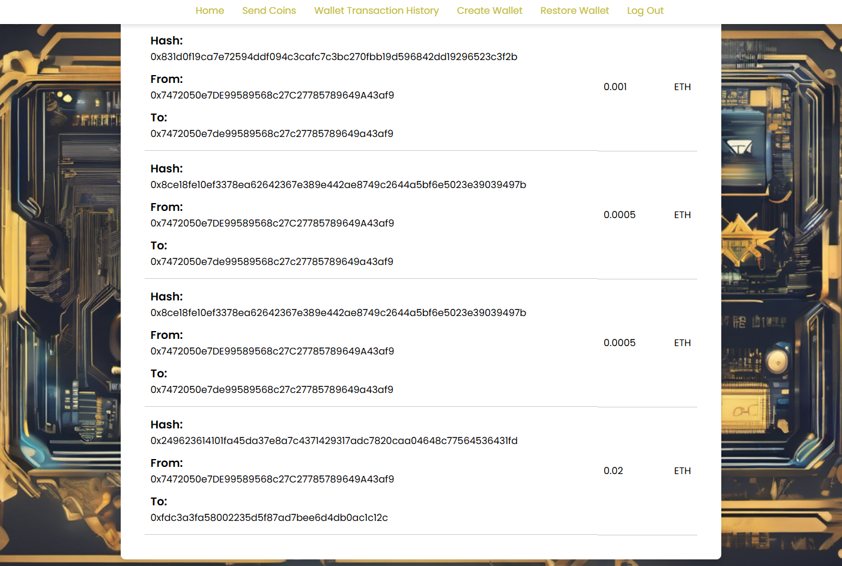

# Restore Wallet

If the user has forgotten their password, it can be restored by inputting a 12-word phrase, which can be accessed via the "Restore wallet" option on the login page.

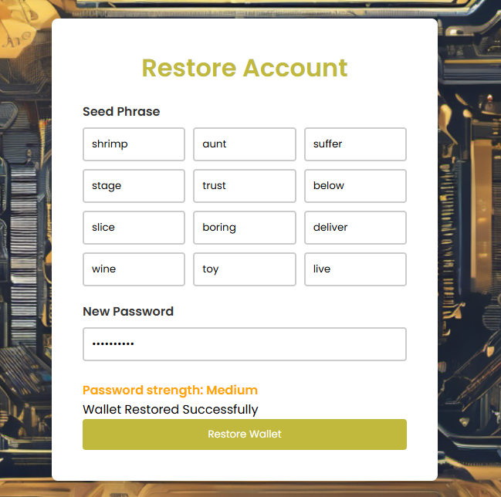

Inputting the correct phrase and a new password should result in the restoration of the user's wallet. The user is then able to return to the login page and enter the relevant information to access their wallet.

# General Tips and Notes

* **Real-Time Data**

User should be connected to Wi-Fi to be able to see real-time data charts, bad connection can lead to not displaying the [Trading view](https://www.tradingview.com/) charts.

* **Networks API’s**

**ETH:** <https://sepolia.infura.io/v3/31dcabced2344e7db2fa98e375858867>

**AVAX:** <https://avalanche-fuji.infura.io/v3/55e824bc56b34aff8b55d07c64d1ff7c>

* **Currencies Prices API’s**

**ETH:**

<https://api.coingecko.com/api/v3/simple/price?ids=ethereum&vs_currencies=usd>

**AVAX:**

<https://api.coingecko.com/api/v3/simple/price?ids=avalanche-2&vs_currencies=usd>